Technology Stack
Team ID | Date | Project | Maximum Marks
SWTID-2026-1237 | 29/09/2026 | EduGenie | 4 Marks

Technical Architecture:
The technical architecture of EduGenie defines the high-level structure of the system, including the presentation layer, application logic layer, AI model integration layer, and infrastructure layer. It illustrates the flow of data between user interface, FastAPI backend built with Python 3.14.4 and Jinja templates, and the external Gemini 3.5 Flash Lite API for intelligent content generation.
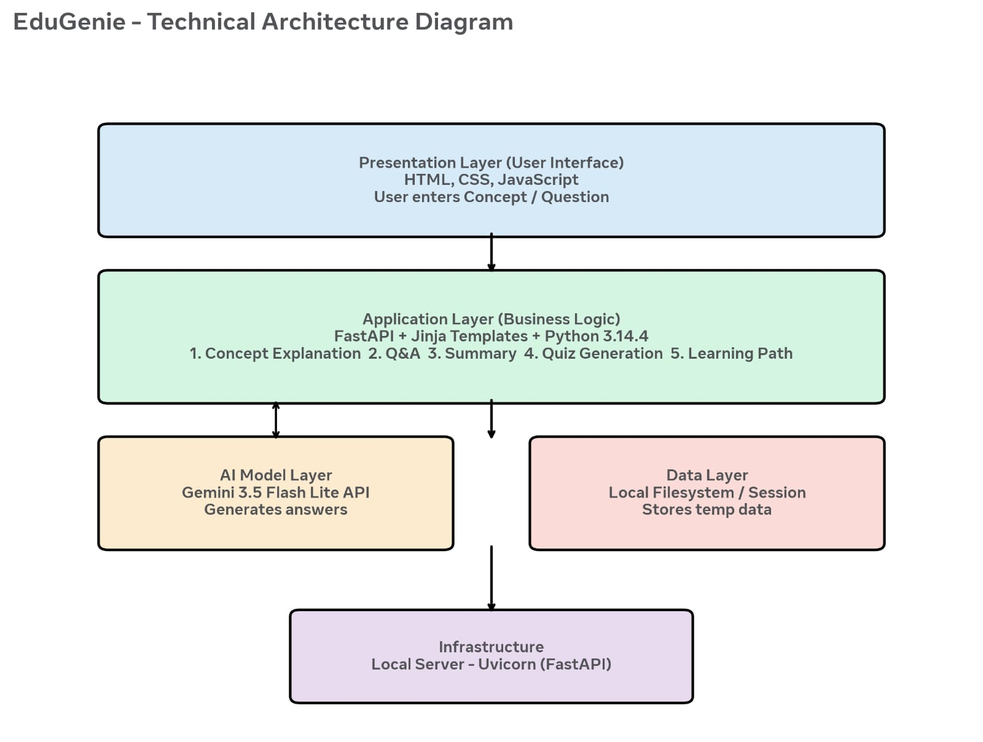

Components and Technologies
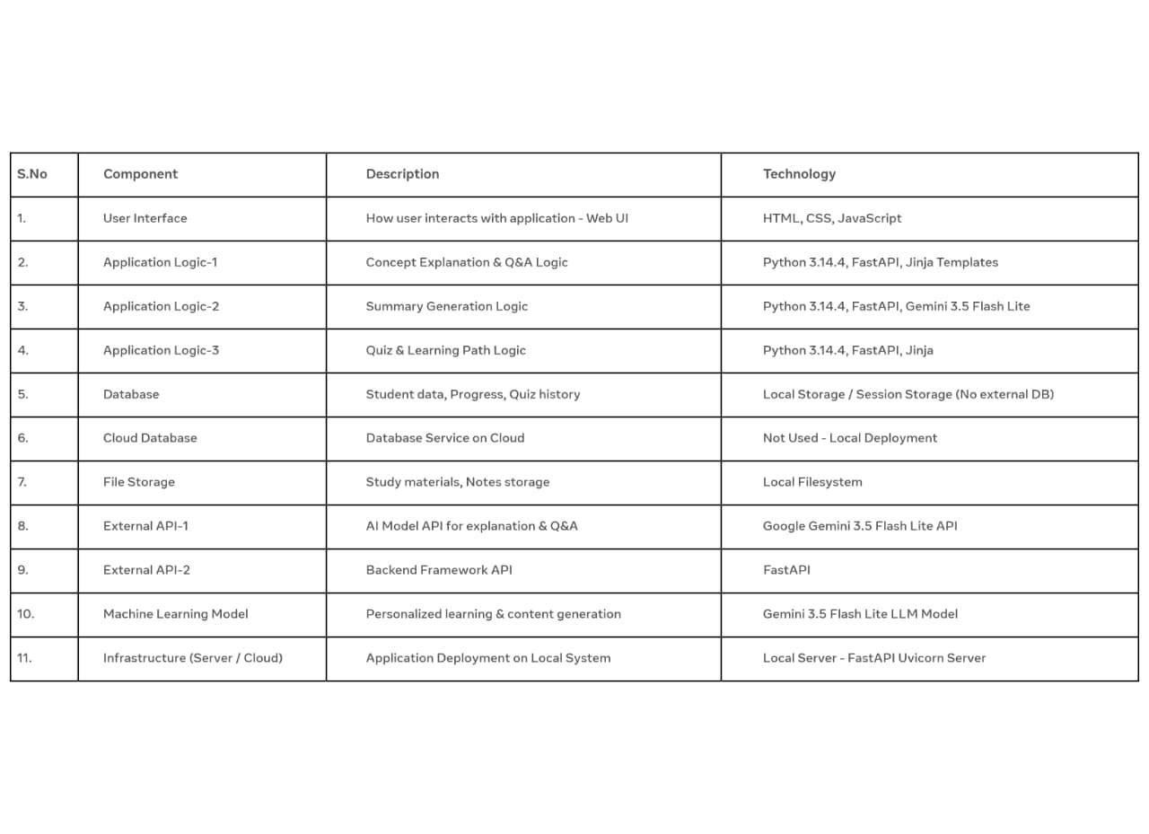
Application Characteristics:
